Department of Computer Science and Engineering


REAL-TIME CHAT APPLICATION IN JAVA
(Socket Programming)


BACHELOR OF TECHNOLOGY
COMPUTER SCIENCE AND ENGINEERING

SUBMITTED TO:

MR. NISHANT THAKUR
MENTOR
JAVA PROGRAMMING

SUBMITTED BY:
NAME: DIVYANKA BABBAR
COURSE: B.Tech. (CSE)
SEMESTER: 5
ROLL NO: 2310303111

TOTAL MEMBERS:

Invertis University, Bareilly [UP]

Project Report (2025-26)

CERTIFICATE

It is to certify that the project report titled “Real-Time Chat Application in Java (Socket Programming)” is an original work, completed in partial fulfillment of the requirements for the degree of Bachelor of Technology in the Department of Computer Science and Engineering at Invertis University.
This project has been carried out under the guidance and supervision of Mr. Nishant Thankur. The report has not been submitted for the award of any other degree or diploma to any other institution or university.
The research presented in this project is a valuable contribution to understanding real-time communication systems, focusing on socket-based networking, client-server interaction, multi-threading, and graphical user interface (GUI) design to support efficient, data-driven, and interactive messaging applications.
I hereby certify that the work embodied in this project report is genuine and has been carried out by me with integrity and dedication.
Mentor: Mr. Nishant Thakur
Department of Computer Science and Engineering
Invertis University

ACKNOWLEDGMENT

I would like to take this opportunity to express my heartfelt gratitude to Mr. Nishant Thakur Sir for his invaluable guidance, encouragement, and continuous support throughout the development of this project, “Real-Time Chat Application in Java (Socket Programming)”. His expert advice, insightful feedback, and constant motivation played a vital role in shaping this work and enhancing its overall quality.
The Real-Time Chat Application project provided me with the opportunity to explore and implement the core concepts of Java socket programming, multithreading, and GUI design using Swing. Through this project, I gained hands-on experience in developing a client-server communication system that supports real-time messaging between multiple users. This helped strengthen understanding of network communication, synchronization, and user interface development.
I would also like to acknowledge the use of various open-source Java libraries and development tools that supported the implementation and testing of this project. These resources were instrumental in building an efficient and user-friendly application.
Lastly, I extend my sincere gratitude to everyone who directly or indirectly supported us during this project. This experience has been immensely insightful and has strengthened my interest in software development, networking, and real-time communication systems.

ABSTRACT

This project explores the development of a Real-Time Chat Application in Java designed to facilitate instant communication between multiple users through a graphical interface. In today’s digital era, real-time messaging applications play a crucial role in enabling fast, reliable, and efficient interaction between individuals and groups.
The system follows a client-server architecture where the server manages multiple client connections using Java socket programming and multithreading. Each connected client can send and receive messages instantly, ensuring seamless communication. The project also integrates a Graphical User Interface (GUI) built using Java Swing, providing a user-friendly environment for chat interaction.
The application demonstrates the use of Java networking concepts, I/O streams, and concurrent programming to achieve real-time message transmission. It highlights how socket-based communication can be implemented securely and efficiently in modern network systems. Ultimately, this project serves as a practical example of combining networking and GUI design to create an interactive, scalable, and reliable chat communication platform.

TABLE OF CONTENT

Title No.
1 | Introduction
2 | System Design and Architecture
3 | Modules of the Project
4 | Tools and Technologies Used
5 | Implementation Details
6 | Output and Results
7 | Challenges Faced During Development
8
  Future Scope and Enhancements
9 | Conclusion

INTRODUCTION
Real-Time Chat Application in Java (Socket Programming)
The Real-Time Chat Application in Java focuses on creating an interactive platform that allows multiple users to communicate instantly over a network. Using socket programming, the project establishes a reliable connection between a central server and multiple clients, enabling real-time data exchange. The system also integrates a Graphical User Interface (GUI) designed with Java Swing, providing users with an intuitive and user-friendly chat environment.
By combining networking principles, multi-threading, and GUI components, this project demonstrates how Java can be used to implement scalable and efficient communication systems capable of handling concurrent users with minimal latency.
Through this project, I explored core programming concepts like socket communication, input/output streams, event handling, and synchronization — all of which are essential for developing distributed applications in modern computing.

Project Overview
The Real-Time Chat Application is designed using the client-server architecture. A central server manages multiple clients by establishing socket-based connections. When a client sends a message, it is broadcast by the server to all connected clients in real time. The GUI allows users to type, send, and view messages instantly, simulating an online chat environment.
Objectives
- To develop a real-time text-based communication system using Java Sockets.
- To implement multi-threading for managing multiple clients concurrently.
- To design a Graphical User Interface (GUI) for better user interaction.
- To achieve reliable and efficient data transmission between clients and the server.
- To understand practical aspects of network programming and concurrency control.
Scope
This project covers:
- Establishing a TCP/IP-based client-server communication model.
- Implementing socket connections for real-time message exchange.
- Designing a responsive chat window using Java Swing components.
- Broadcasting messages to all active clients using server-side threading.
- Handling client connection, disconnection, and message synchronization efficiently.
Expected Outcomes
- Functional real-time group chat system with GUI support.
- Improved understanding of Java networking and socket programming.
- Ability to manage multiple concurrent client connections.
- Practical exposure to GUI-based application design.

Importance of Real Time Chat Application
Understanding and developing real-time chat systems are crucial in today’s interconnected world. Such applications not only enhance personal communication but also support collaboration in education, business, and remote work environments.
Enhances Connectivity
Provides a platform for instant text communication between users across different systems or networks.
Promotes Collaboration
Facilitates group discussions and teamwork by enabling seamless exchange of information.
Real-Time Interaction
Instant message transmission ensures users can communicate without delays, improving responsiveness and engagement.
Practical Learning of Networking Concepts
Helps students and developers understand real-world implementation of sockets, multi-threading, and data streams in Java.
Supports Secure Communication
Lays the foundation for integrating encryption and authentication features in future versions for safe message exchange.

System Reliability and Accuracy
System reliability in a chat application refers to maintaining consistent and timely message delivery among connected users, even when multiple clients are active. High reliability ensures smooth communication and user satisfaction.
Why It Matters
- Ensures all users receive messages instantly and accurately.
- Prevents message loss during concurrent communication.
- Improves user trust and experience.
- Strengthens overall network stability and scalability.
How to Improve Reliability
- Implement efficient multi-threading and error handling.
- Maintain message synchronization using synchronized I/O streams.
- Use proper socket closure to handle client disconnections.
- Introduce features like message delivery acknowledgment in future updates.

SYSTEM DESIGN AND ARCHITECTURE
The Real-Time Chat Application in Java is built using a client-server architecture, where a single server manages multiple clients simultaneously. It enables users to exchange text messages in real time through socket-based communication. The system is designed to ensure reliability, scalability, and ease of use by integrating Java socket programming, multithreading, and a Graphical User Interface (GUI) built using Swing.

2.1 System Architecture Overview
The system consists of two major components:
1. Server Module
- Acts as the central communication hub.
- Listens for incoming client connections through a ServerSocket on a fixed port (e.g., 12345).
- For every connected client, a separate thread (ClientHandler) is created to handle message exchange independently.
- When a client sends a message, the server broadcasts it to all other connected clients.
2. Client Module
- Connects to the server using a Socket and the same port number.
- Sends user-inputted messages to the server.
- Receives broadcast messages from the server and displays them in the chat area.
- The GUI provides fields for message input and a display window for chat messages.

2.2 Architectural Flow
1. Server Initialization:
The server starts and begins listening for incoming connections on a specific port.
2. Client Connection:
A client enters their username and connects to the server through TCP/IP protocol.
3. Thread Assignment:
The server creates a new ClientHandler thread for each connected client.
This allows the server to handle multiple users concurrently without delays.
4. Message Transmission:
- When a user types a message and clicks “Send,” the message is sent to the server.
- The server receives the message and broadcasts it to all connected clients except the sender.
5. GUI Display:
The client application displays messages in a text area, differentiating between “You” and other users.
6. Client Disconnection:
When a user closes the chat window or disconnects, the server removes their thread and notifies other users.

2.3 Data Flow Diagram (Conceptual)
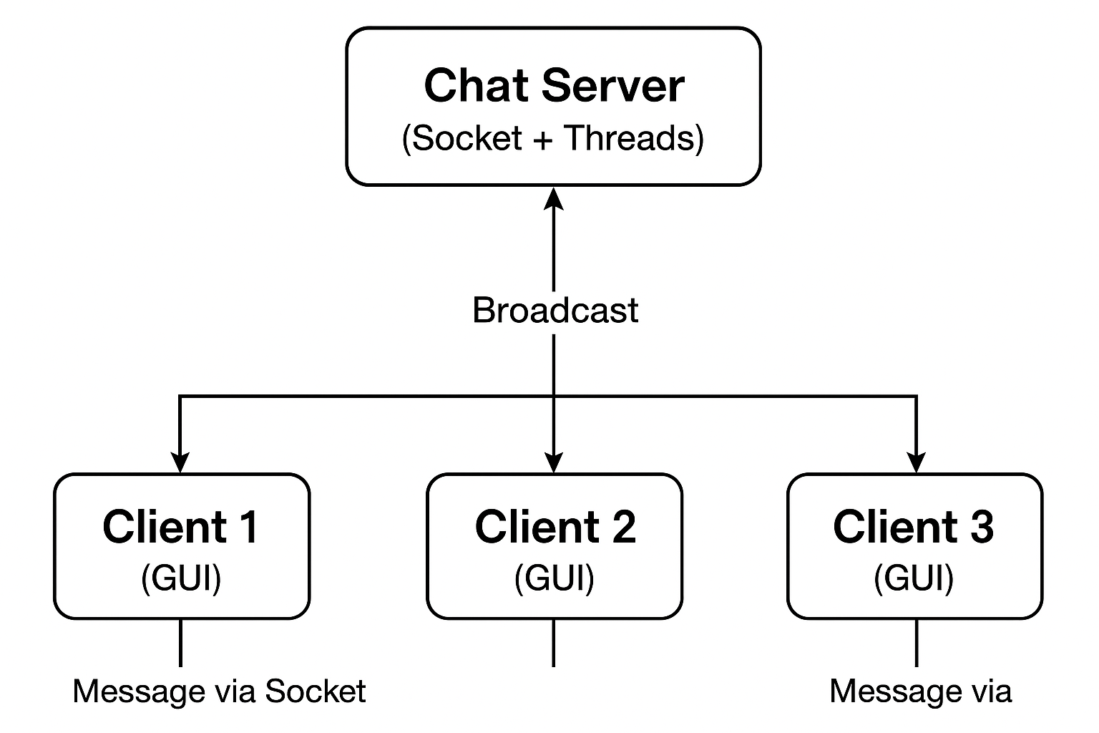
Explanation:
- Each client communicates with the server through TCP sockets.
- The server acts as a relay — any message received is distributed to all other connected clients.
- The architecture ensures real-time bidirectional data flow.

2.4 Key Components

Component | Description
ChatServer.java | Creates a server socket and accepts client connections. Spawns new threads for each client.
ClientHandler.java | A multithreaded class responsible for handling communication for each connected client.
ChatClientGUI.java | Client-side GUI application where users can send and receive chat messages.
Socket & ServerSocket | Core networking classes for establishing and maintaining connections.
I/O Streams | Used for reading and writing text messages across the network.

2.5 Communication Model
- Protocol Used: TCP/IP
- Mode: Full-Duplex Communication
- Connection Type: Persistent (remains open until explicitly closed)
- Data Format: Text-based message exchange using PrintWriter and BufferedReader
This architecture ensures low latency, high reliability, and real-time message delivery between all connected users.

2.6 Advantages of the System Design
- Supports multiple clients simultaneously via threading
- Reliable and fast communication using TCP sockets
- Easy-to-use and interactive GUI interface
- Modular design — separate server, client, and handler components
- Extensible — future upgrades like encryption or file sharing can be added

3. MODULES OF THE PROJECT
The Real-Time Chat Application in Java is divided into several interdependent modules that work together to achieve efficient, real-time communication between users. Each module performs a specific function within the overall client-server architecture, ensuring seamless data flow, message handling, and user interaction through the GUI.
The system’s modular structure enhances scalability, maintainability, and clarity, allowing future developers to extend the project with new features such as encryption, file sharing, or user authentication.

3.1 Chat Server Module
Purpose:
This is the backbone of the entire system. The Chat Server listens for incoming client connections on a predefined port and manages all communication between users. It ensures that every message sent by a client is received by all other connected clients in real time.
Functions:
- Initializes a ServerSocket and waits for client requests.
- Creates a new thread (ClientHandler) for each connected user.
- Receives messages from clients and broadcasts them to all others.
- Handles user connection and disconnection gracefully.
Key Classes & Components:
- ServerSocket
- Socket
- ChatServer.java
- ClientHandler.java
Responsibilities:
- Maintain active connections.
- Control synchronization between multiple clients.
- Ensure no data loss or message duplication during broadcast.

3.2 Client Handler Module
Purpose:
The ClientHandler module manages the communication between the server and an individual client. It operates as a separate thread, ensuring that the server can handle multiple clients simultaneously without blocking.
Functions:
- Continuously listens for messages from the connected client.
- Forwards received messages to the server for broadcasting.
- Detects client disconnection and removes them from the active user list.
Key Classes & Components:
- ClientHandler.java
- BufferedReader and PrintWriter for I/O communication
- Thread management using the Thread class
Responsibilities:
- Enable concurrent communication.
- Maintain real-time synchronization of messages.
- Improve server performance by separating client workloads.

3.3 GUI Client Module
Purpose:
This module provides a Graphical User Interface (GUI) for user interaction. It allows users to send and receive messages conveniently without relying on the console. The GUI enhances usability and makes the chat experience intuitive and visually appealing.
Functions:
- Displays chat messages in a scrolling text area.
- Provides a text field for user input.
- Includes a Send button and key event listener for sending messages.
- Differentiates between sent and received messages (“You:” prefix for own messages).
Key Classes & Components:
- ChatClientGUI.java
- JFrame, JTextArea, JTextField, JButton, JPanel (Swing components)
- ActionListener and event handling
Responsibilities:
- Establish socket connection with the server.
- Handle message input/output between user and server.
- Update chat window in real-time.

3.4 Communication Module
Purpose:
The Communication Module ensures smooth message exchange between the client and the server through socket programming. It defines how messages are sent, received, and processed in real time.
Functions:
- Manages socket connection establishment and termination.
- Handles I/O streams for sending and receiving messages.
- Ensures message reliability using TCP protocol.
- Enables full-duplex communication between clients via the server.
Key Classes & Components:
- Socket
- ServerSocket
- InputStreamReader, OutputStreamWriter, BufferedReader, and PrintWriter
Responsibilities:
- Maintain a stable and persistent connection.
- Prevent message loss or corruption.
- Facilitate fast and synchronized message delivery.

3.5 Multithreading Module
Purpose:
This module allows the system to handle multiple clients at once by assigning each connection to a separate thread. Without multithreading, only one user could interact with the server at a time.
Functions:
- Creates a new thread for every connected client.
- Handles parallel message processing and broadcasting.
- Prevents server blocking or lag during heavy traffic.
Key Classes & Components:
- Thread class and its run() method
- synchronized blocks for shared resource management
Responsibilities:
- Enable concurrent operations.
- Ensure responsiveness and stability under multiple connections.

3.6 Utility Module (Optional Extension)
Purpose:
This module manages additional helper functions such as user authentication, message formatting, and logging. It serves as a foundation for enhancing system features in future updates.
Functions:
- Validate user input and connection data.
- Log message history or connection events.
- Format timestamps for chat messages.
Future Enhancements:
- Add encryption for secure messaging.
- Store chat logs in a database.
- Implement user login and registration.

3.7 Summary of Modules

Module Name | Primary Function | Key Class/Feature
Chat Server Module | Manage client connections and broadcast messages | ChatServer.java
Client Handler Module | Handle client threads and message forwarding | ClientHandler.java
GUI Client Module | Provide user interface for chat interaction | ChatClientGUI.java
Communication Module | Handle socket-based message exchange | Socket, ServerSocket
Multithreading Module | Manage multiple clients simultaneously | Thread, Runnable
Utility Module (Future) | Additional services like logging, encryption | FileWriter, Timestamp

4. TOOLS AND TECHNOLOGIES USED
The development of the Real-Time Chat Application in Java (Socket Programming with GUI) involves the integration of several programming tools, libraries, and technologies. These tools enable efficient development, testing, and execution of both server and client components while ensuring reliability, scalability, and a smooth user experience.
Each component of the application — networking, threading, and graphical interface — utilizes Java’s built-in libraries and frameworks to implement real-time communication with minimal latency.

4.1 Programming Language
Java (JDK 8 or above)
- The project is entirely developed in Java, chosen for its platform independence, robust networking API, and built-in support for multithreading.
- Java’s java.net and java.io packages provide a strong foundation for socket-based communication.
- Its Swing framework offers a rich set of components for building interactive GUIs.

4.2 Development Environment
Integrated Development Environments (IDEs):
- IntelliJ IDEA / Eclipse / VS Code were used for writing, compiling, and testing the code.
- These IDEs provide features like syntax highlighting, debugging tools, and integrated build support, making the development process faster and more efficient.

4.3 Networking Technology
Java Socket Programming (TCP/IP Protocol)
- The application uses TCP (Transmission Control Protocol) to establish a reliable, two-way communication channel between clients and the server.
- The ServerSocket class listens for incoming connections, while the Socket class handles data exchange between client and server.
- This ensures real-time message delivery without packet loss.

4.4 Multithreading
Java Thread Class and Runnable Interface
- Each connected client runs on a separate thread, allowing multiple users to chat simultaneously without blocking other connections.
- The ClientHandler class extends Thread and executes independently, maintaining concurrency in the server’s operations.
- Thread synchronization ensures message consistency and prevents data corruption.

4.5 Graphical User Interface (GUI)
Java Swing Framework
- The client interface is built using Swing components such as JFrame, JTextArea, JTextField, JButton, and JPanel.
- Swing provides a lightweight, platform-independent GUI toolkit that makes it easy to create responsive and interactive windows.
- The layout ensures simplicity, with a scrollable chat area and a text input field for user convenience.

4.6 Input/Output Streams
I/O Classes Used:
- BufferedReader → For reading text messages from input streams.
- PrintWriter → For sending text messages to output streams.
- These classes provide efficient and buffered communication between the client and the server.
Key Benefits:
- Reduces communication delay.
- Handles text messages efficiently.
- Simplifies data reading/writing across the network.

4.7 Operating System Compatibility
- Compatible with Windows, Linux, and macOS.
- Platform independence is achieved through Java’s Write Once, Run Anywhere (WORA) capability.

4.8 Additional Utilities and Tools
Tool / Library | Purpose
Java AWT & Swing | Used for GUI design and event handling.
java.net & java.io | For socket communication and stream handling.
Threads & Synchronization | For managing concurrent client communication.
JVM (Java Virtual Machine) | Executes compiled bytecode across platforms.
Command Line / Terminal | Used to run server and multiple client instances.

4.9 Version Control (Optional)
Git / GitHub
- Version control tools like Git can be used to maintain source code versions, track changes, and collaborate with other developers.
- Helps ensure safe code storage and easy rollback to previous versions.

4.10 Summary
The combination of Java Socket Programming, Multithreading, and Swing GUI Framework enables this project to function as a reliable, user-friendly, and scalable chat platform.
The modular integration of these technologies ensures that the system is both robust and easy to maintain, forming a strong foundation for future enhancements like encryption, file transfer, or database connectivity.

5. IMPLEMENTATION DETAILS
The Real-Time Chat Application in Java (Socket Programming with GUI) is implemented using the client-server model, where multiple clients connect to a single server and communicate in real time. The project is divided into three main parts — Server, Client Handler, and GUI Client — each implemented in Java for efficiency and portability.

5.1 Server Implementation
The server acts as the central hub for managing all client connections.
It uses a ServerSocket to listen on a specific port (e.g., 12345) and accepts new client requests.
Each client is handled by a separate thread to enable simultaneous communication.
Key tasks:
- Accept client connections.
- Create and manage individual ClientHandler threads.
- Broadcast messages to all connected clients.

5.2 Client Handler Implementation
Each ClientHandler runs as an independent thread responsible for communicating with a single client.
It continuously reads messages from the client and forwards them to the server for broadcasting.
Key tasks:
- Receive messages from the assigned client.
- Relay messages to the server.
- Remove disconnected clients safely.

5.3 GUI Client Implementation
The client-side program provides a Graphical User Interface (GUI) built using Java Swing.
It includes a chat area, input field, and send button.
When a user types a message and clicks “Send,” the message is sent to the server and displayed instantly in the chat window.
Main components:
- JTextArea → Displays chat messages.
- JTextField → Takes message input.
- JButton → Sends message on click.

5.4 Communication Process
- The client connects to the server using a Socket and exchanges messages through I/O streams.
- The server relays each received message to all other connected clients using TCP.
- The system ensures real-time delivery and maintains connection stability.

5.5 Execution Flow
- Run the server: java ChatServer
- Start one or more clients: java ChatClientGUI
- Enter username and start chatting in real time.

5.6 Output
Each client can view:
- Their own message (You: ...)
- Messages from other users
- Notifications when users join or leave the chat

6. OUTPUT AND RESULTS
The Real-Time Chat Application in Java (Socket Programming with GUI) successfully demonstrates how multiple users can communicate simultaneously through a central server using TCP sockets and multithreading. The output validates the effectiveness of socket programming and the user-friendly interface built with Swing.

6.1 Server Output
- When the server starts, it displays a message such as:
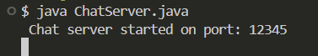
- As clients connect, the server shows:
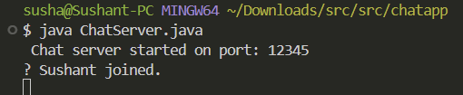
- When clients send messages:
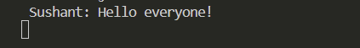

6.2 Client Output (GUI Interface)
Each client sees a chat window with:
- A scrollable text area displaying all messages in real time.
- A text box to type new messages.
- A send button to deliver messages instantly
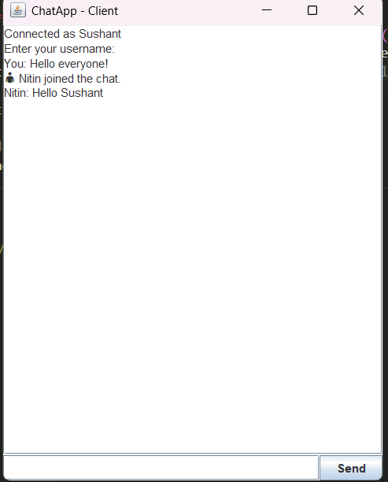

6.3 Result Summary
- Real-time message transmission between multiple users.
- Smooth GUI with instant message updates.
- Reliable connection using TCP sockets.
- Proper handling of client join/leave events

7. CHALLENGES FACED DURING DEVELOPMENT
During the development of the Real-Time Chat Application in Java, several technical and logical challenges were encountered, especially while implementing networking and multithreading together. Overcoming these challenges helped strengthen understanding of Java’s networking model and real-time system design.

7.1 Managing Multiple Client Connections
Handling multiple users simultaneously was challenging in the beginning.
The issue was resolved using multithreading, where each client connection runs on a separate ClientHandler thread to maintain smooth communication.

7.2 Synchronization of Messages
Ensuring that all clients receive messages in real time without delay or duplication required careful synchronization.
This was managed by using synchronized blocks and proper thread handling in the broadcast() method of the server.

7.3 Handling Client Disconnections
When a client suddenly closed the application, it initially caused socket exceptions and thread interruptions.
The issue was fixed by implementing try-catch blocks and graceful client removal from the server list.

7.4 GUI Responsiveness
Integrating networking with GUI sometimes made the interface lag.
To solve this, background threads were used for message reading, keeping the Swing interface responsive and user-friendly.

7.5 Testing Multiple Instances
Testing required running multiple clients simultaneously on one machine.
This was achieved by running several Java client instances connected to the same local server using localhost and the same port.

7.6 Summary
These challenges enhanced understanding of:
- Multithreaded programming
- Socket communication
- GUI and event-driven design
- Exception handling and debugging

8. FUTURE SCOPE AND ENHANCEMENTS
The Real-Time Chat Application in Java serves as a foundational model for understanding client-server communication, but it has significant potential for expansion and improvement. The following enhancements can make the system more powerful, secure, and user-friendly in the future.

8.1 User Authentication System
- Add a login and registration feature using a database (e.g., MySQL or SQLite).
- Store usernames and passwords securely for personalized access.

8.2 Message Encryption
- Implement end-to-end encryption to secure communication between clients.
- Ensure that only intended recipients can read transmitted messages.

8.3 File Sharing Feature
- Allow users to send and receive images, documents, or files through the same chat interface.
- Utilize Java’s FileInputStream and FileOutputStream classes for data transfer.

8.4 Chat History and Storage
- Store chat messages in a database or text file for future retrieval.
- Enable users to view previous conversations upon reconnection.

8.5 Improved GUI Design
- Enhance the GUI with modern JavaFX components or themes.
- Include features like emojis, timestamps, and user profile icons.

8.6 Scalability and Cloud Hosting
- Host the chat server on a cloud platform (AWS, Azure, or Google Cloud) to handle a larger number of users.
- Implement load balancing for better performance under heavy traffic.

8.7 Summary
The project lays a strong foundation for building more advanced communication systems.
By adding features like encryption, authentication, file transfer, and cloud deployment, it can evolve into a complete, secure, and scalable real-time messaging platform.

9. CONCLUSION
The Real-Time Chat Application in Java (Socket Programming with GUI) successfully demonstrates how multiple users can communicate simultaneously through a central server using Java sockets, multithreading, and Swing GUI.
This project provided practical exposure to the client-server architecture, where the server manages multiple client connections efficiently, ensuring real-time message broadcasting with minimal delay. It also enhanced understanding of network communication, concurrent programming, and event-driven interface design.
Through this implementation, the importance of synchronization, reliable data transmission, and user interface responsiveness became clear. The project highlights how core Java concepts can be combined to build scalable, interactive applications that mimic modern chat systems.
Overall, the project achieved its objectives — building a real-time, GUI-based communication system that is both functional and extendable. It also serves as a strong foundation for future development, where features like encryption, database integration, and file transfer can transform it into a complete real-world messaging platform.

